|  |  |  |  |  |
| --- | --- | --- | --- | --- |
| **Jurnal**  **Teknologi** |  | | | **Full Paper** |
|  |  | | |  |
|  |  | | |  |
| **Extracting blink rate variability based on EEG signals**  Temesgen Gebrehiwot, Rafal Paprocki , Artem Lenskiy*  School of Electronics and Communication Engineering, Korea University of Technology and Education | | | **Article history**  Received  *TBA*  Received in revised form  *TBA*  Accepted  *TBA*  *Corresponding author  lensky@koreatech.ac.kr | |
|  | | | | |
| **Graphical abstract** | | **Abstract**  We studied the importance of eye blinks from various directions and we designed and a new approach in detecting eye blinks | | |
| © 2015 Penerbit UTM Press. All rights reserved | | |
|  | |  | | |

**1.0 INTRODUCTION**

Blinking is a semi-autonomic closing of the eye lids. Every time we blink, o ur eyelids spread a cocktail of oils and mucous secretions across the surface of the eye to keep your globes from drying out. Blink also keeps eyes protected against potentially damaging stimuli, such as bright lights and foreign bodies like dust. So why don't we notice the world plunging into darkness every two to ten seconds? The sudden changes in an image due to saccades or blinks, do not interfere with our subjective experience of continuity [29], the very act of blinking suppresses an activity in several areas of the brain responsible for detecting environmental changes, so that you experience the world as continuous. Researches have shown the synchronous behavior in blinking between listener and speaker in face-to-face conversation [19]. Each blink spreads the tears on the eye cornea to moisture and disinfect the eye. Reduced blink rate causes eye redness and dryness also known as Dry Eye, which belongs to the major symptoms of the Computer Vision Syndrome[20].

The blinks have been known to be linked to interior brain activities. Increasing the accuracy of blink detection is of high importance as humans look for an easier method of collecting internal brain activity information. The detection of the eye blinks had a huge impact in various fields in some BCI (Brain Computer Interface) they detected eye blinks and determined the pattern with the duration after collecting this analysis, they used it in as an input to a computer in similar manners that we use our mouse. This implementation of the use of blinks has opened a wide door to new possibilities for disabled people [28]. World Health Organization (WHO) has announced that the ninth purpose of death globally are car accidents. National Motor Vehicle Crash Causation Survey (NMVCCS) has found that 30% of car accidents are made happen by the drowsiness of drivers [30]. It is noted that workload increase heart rate and heart rate are known to decrease in monotonous and drowsy conditions [25]. BR is inversely correlated with the increase of workload so blinks can be used to detect drowsiness before it creates damage [25]. Researchers have shown that blinks can play an significant role in detecting many difference brain disorder and brain activities, Spontaneous blink rate(BR) has been studied in many neurological diseases like Parkinson's disease and Tourette syndrome[1][2][3]. The use of blink detection does not stop there. Researchers have found that blink rates can be used as a source of data in detecting psychiatric disorders like schizophrenia and attention hyperactivity all this is because blinks are regarded as a non-invasive peripheral markers of the central dopamine activity which makes their accurate detection more important [4] [5] [6] [7] [8] [9]. Researchers have studied the synchronousness of the eye blinks in audience, who experienced the same transportation of storytelling. The eye blink synchronization among audiences is driven by attention cycles, which are in turn driven by emotional processing [16][17][18]

Blinks are not always the most desired signals when it comes to non-invasive brain signal measuring as many electroencephalography (EEG) remove them to acquire brain data. Eye blink is one of the main artifacts in the EEG signal[21 ]. Researchers are focusing on removing these signals to obtain real brain signal values. Many researchers have mentioned how removing blinks can cause from small to measure the effect on the recorded data, so we can understand how the accurate detection can help in the removal of only the blink data.

Understanding the importance of blinks we proposed a new approach in dealing with blinks. We extract blink rates form EEG signals by using fast ica algorithm as a solution for blind signal separation.

**2.0 EXPERIMENTAL**

**2.1 Data acquisition**

For the purpose of collecting data, we developed special questionnaire software, and software for detecting eye blinks within EEG signals.

The video stream was captured with a Logitech HD Pro Webcam C920. Video stream was stored on a disk drive to be processed in the future. Simultaneously, EEG signals were recorded. For the recording of EEG signals, we employed Mitsar-EEG 201 amplifier and accompanying WinEEG software. The electrodes were placed according to the international “10-20 system” [15]. Electro-gel has been injected into electrodes hollow in order to decrease the electrode-skin resistance. Currently, the EEG signals were recorded for the purpose of eye blink detection. In the future work we are planning to analyze EEG to detect various types of brain activity.

The experimental setup is shown in the figure 1.

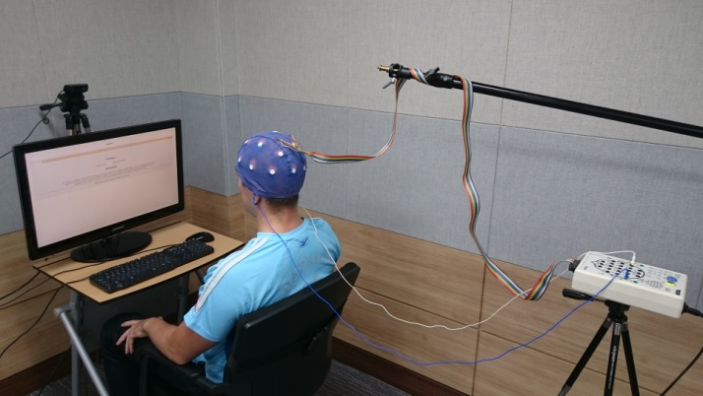

Figure 1 Experimental setup

**2.2 Testing procedure**

The recording session consisted of five stages: (a) resting, (b) the IQ test, (c) resting, (d) reading, and (e) the memory test. The testing software was developed in Java in such a way that it does not require any interventions. The whole testing session took 30 minutes, 5 minutes resting before the IQ, 10 minutes the IQ test, 5 minutes resting stage, 5 minutes reading and 5 minutes the memory test. Before the memory test a resting stage and passage about Ethiopia was given. After reading the passage user was presented questions one by one. In the figure 2 an example of a memory test question is shown.

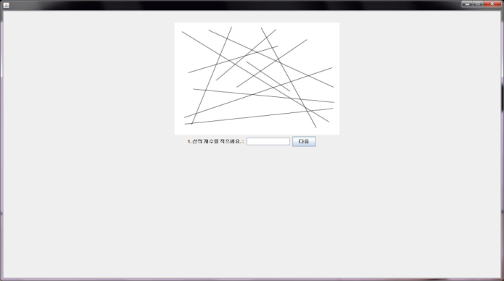 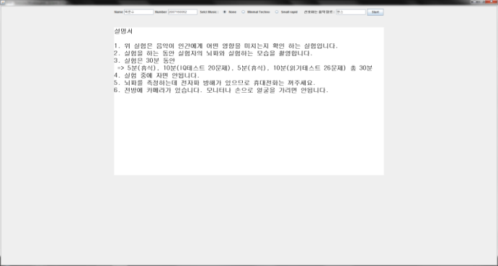

Figure 2 User’s interface

**3.0 Eye blink detection procedure**

EEG signals were recorded while participants were taking the tests and later, in form of CSV files, imported by the developed software to analyze. The process of blink detection can be summarized for each stage in the following steps: (a) bandpass filtering (b) fastICA on EEG signal (c) choosing blink component (d) treesholding (e) detecting blinks (f) calculating blinks rate variability.

Electrodes are applied to the head according to 10-20 system. Electrode placement has been standardized in order to fit anatomical skull landmarks. Name ’10-20’ comes from the fact, the distance between nasion, the inion and the head circumference, marking electrode locations based on 10% or 20 % intervals of those distances. We used bipolar montage, which means we determine the potential between Fp1 and Fp3, also Fp2 and Fp4. Figure 3 presents EEG signals for both pairs. In figure 4 we can find the very same signals but after bandpass filtering and normalization.



Figure 3 Fp1-Fp3 and Fp2-Fp4 electrode pairs



Figure 4 Bandpass filtering

Usually we want to get rid of ocular artifacts from EEG signal, as the eye blink is artifact and leads to interpretation problems [24]. This time we are going to extract blinks from EEG. In order to do that we employ fastICA[38] algorithm for solving Blind Source Separation (BSS)[39], which allows us to separate neural activity from muscle and blink artifacts[40]. ICA algorithm consists of two stages. First is decorrelation or whitening, we remove any correlations in the data.

Let $x_{st} = {S }^{\frac{1}{2}} \left({ F}_{x} \right)\left(x - μ\left({ F}_{x} \right)\right)$ be the data whitened using the mean vector $μ({ F}_{x} )$ and the covariance matrix $S \left({ F}_{x} \right)$.

Second stage is separation, which is orthogonal transformation of whitened signals (rotation of the joint density). The task is to find an orthogonal matrix $U$ such that ${U x}_{st}$ has independent components [38]. One by one we are looking for the rows of the matrix $U = {(u_{1} , . . . , u_{p} )}^{T}$ so a measure of non-Gaussianity $|E(G(u_{k}^{T} x_{st} ))|$ is maximized by such $u_{k}$ that the length of $u_{k}$ is one and orthogonal to rows $(u_{1} , . . . , u_{k-1} )$. The function $G$ can be any nonquadratic function, which is twice continuously differentiable with $G(0) = 0$ and with first and second derivative functions $g$ and $g'$.

Nonlinearity is defined as the derivative function $g = G '$. Variety of optimizing criterions (cost functions) can be used. By choosing kurtosis measure we obtain the nonlinearity $g(z) = z^{3}$ ($pow3$). Another choice could be functions $g(z) = tanh(az)$ ($tanh$) and $g(z) = zexp(\frac{-az^{2}}{2})$ ($gaus$) properly parameterized [31]. The $g(z) = z^{2}$ ($skew$) we can get from skewness measure. There exist some general directions of choosing nonlinearity for fastICA algorithm. For example, the $g(z) = z^{3}$ ($pow3$) nonlinearity is efficient for sources with light-tailed distributions. For heavy-tailed sources $g(z) = tanh(az)$ ($tanh$)and $g(z) = zexp(\frac{-az^{2}}{2})$ ($gaus$) are desirable. The $g(z) = z^{2}$ ($skew$) nonlinearity finds skew sources but in the case of symmetric sources is not efficient. Therefore in practice, $tanh$ and $gaus$ nonlinearities are common choices. As a result we obtain two independent components, as presented in figure 5. Based on comparing of sums of both components, we decide which one of two is blinking one and set heuristically obtained threshold, as shown in figure 6. For all candidates we calculate length of characteristic polynomials and reject these with too short length. Final result we can observe in figure 7.



Figure 5 Independent components



Figure 6 The top graph shows the threshold signal



Figure 7 Detected blinks



Figure 8 Zoomed version of the previous figure

We do know where blink appeared in blink independent component, therefore we can calculate blink rate variability (figure 9).



Figure 9 Extracted blink rate variability

**4.0 RESULTS AND DISCUSSION**

Figure 10 compares BRV for all the subjects during memory test. The X-axis is blink interval where Y-axis presents interval lengths per each subject.



Figure 10 Extracted blink rate variability for each subject

**5.0 CONCLUSION**

In this paper, we discuss fastICA algorithm as a solution for problem of extracting the eye blinks from EEG signal treated as Blind Signal Separation. We used “10-20 system” electrode placement system with a bipolar montage for two electrodes, thus as total four electrodes have been used. This count of electrodes is enough to capture good EEG data for eye blinking. Presented results demonstrate high efficiency of incorporated method. The results of this study give us chance to use it in further research.

**Acknowledgement**

**References**

1. Agostino R, Berardelli A, Cruccu G, Stocchi F, Manfredi M. Corneal and blink reflexes in Parkinson’s disease with ‘on–off’ fluctuations. Mov. Disord. 1987; 2: 227–235.

2. Shlik J, Zhou Y, Koszycki D, Vaccarino FJ, Bradwejn J. Effects of CCK-4 infusion on the acoustic eye-blink startle and psychophysiological measures in healthy volunteers. J. Psychopharmacol. 1999; 13: 385–390.

3. Karson CN, Kaufmann CA, Shapiro AK, Shapiro E. Eye-blink rate in Tourette’s syndrome. J. Nerv. Ment. Dis. 1985; 173: 566–569.

4. Chen EY, Lam LC, Chen RY, Nguyen DG. Blink rate, neurocognitive impairments, and symptoms in schizophrenia. Biol. Psychiatry 1996; 40: 597–603.

5. Helms PM, Godwin CD. Abnormalities of blink rate in psychoses: A preliminary report. Biol. Psychiatry 1985; 20: 103–106.

6. Mackert A, Woyth C, Flechtner KM, Volz HP. Increased blink rate in drug-naive acute schizophrenic patients. Biol. Psychiatry 1990; 27: 1197–1202.

7. Sandyk R. The significance of eye blink rate in parkinsonism: A hypothesis. Int. J. Neurosci. 1990; 51: 99–103.

8. Jacobsen LK, Hommer DW, Hong WL et al. Blink rate in childhood-onset schizophrenia: Comparison with normal and attention-deficit hyperactivity disorder controls. Biol. Psychiatry 1996; 40: 1222–1229.

9. Karson CN, Dykman R, Paige SR. Blink rates in schizophrenia. Schizophr. Bull. 1990; 16: 345–354.

[15] Malmivuo J., Plonsey R., Bioelectromagnetism, Principles and Applications of Bioelectrical and Biomagnetic Fields, page 258, New York, Oxford, Oxford University Press, 1995, http://www.bem.fi/book/

[16] Ryota Nomura 1 *, Kojun Hino 2 , Makoto Shimazu 3 , Yingzong Liang 4 and Takeshi Okada 1, Emotionally excited eyeblink-rate variability predicts an experience of transportation into the narrative world

[17] Nomura, R., and Okada, T. (2014). Spontaneous synchronization of eye-blinks during story-telling performance. Cogn. Stud. 21, 226–244. doi:10.11225/jcss.21.226

[18] Nakano, T., Yamamoto, Y., Kitajo, K., Takahashi, T., and Kitazawa, S.(2009). Synchronization of spontaneous eyeblinks while viewing video stories. Proc. R. Soc. B Biol. Sci. 276, 3635–3644. doi: 10.1098/rspb.2009.0828

[19] Nakano, T., and Kitazawa, S. (2010). Eyeblink entrainment at breakpoints of speech. Exp. Brain Res. 205, 577–581. doi: 10.1007/s00221-010-2387-z

[20] Patrik POLATSEK, Eye Blink Detection. Slovak University of Technology in Bratislava. Faculty of Informatics and Information Technologies. IIT.SRC 2013, Bratislava, April 23, 2013, pp. 1–8.

[24] Croft R.J., Barry R.J. Removal of ocular artifact from the EEG: A review. Clin. Neurophysiol. 2000;30:5–19

[25] Barbato G., Ficca G., Muscettola G., Fichele M., Beatrice M., Rinaldi F. Diurnal variation in spontaneous eye-blink rate. Psychiatry Res. 2000;93:145–151.

[28] Real Time Eye Tracking and Blink Detection with USB Cameras. Michael Chau and Margrit Betke Computer Science Department Boston University Boston, MA 02215, USA {mikechau, [betke@cs.bu.edu](mailto:betke@cs.bu.edu)} May 12, 200

[29] Responses of Primate Visual Cortical Neurons to Stimuli Presented by Flash, Saccade, Blink, and External Darkening TIMOTHY J. GAWNE AND JULIE M. MARTIN Department of Physiological Optics, University of Alabama at Birmingham, Birmingham, Alabama 35294 Received 1 March 2002; accepted in final form 24 July 2002

[30] National Motor Vehicle Crash Causation Survey(NMVCCS)

[31] A. Hyv ̈arinen, “Fast and Robust fixed-point algorithms for independent component analysis,” IEEE Trans. Neural Networks, vol. 10, pp. 626-634, 1999.

[38] Jari Miettinen, Klaus Nordhausen, Hannu Oja and Sara Taskinen. Deflation-based FastICA with adaptive choices of nonlinearities. IEEE TRANSACTIONS ON SIGNAL PROCESSING, VOL. , NO. , 2014

[39] Pierre Comon Independent component analysis, A new concept?. Signal Processing 36 (1994) 287-314

[40] Bell, A. J., & Sejnowski, T. J.1995. an information-maximization approach to blind separation and blind deconvolution.

Neural Computation,7, 1129–1159